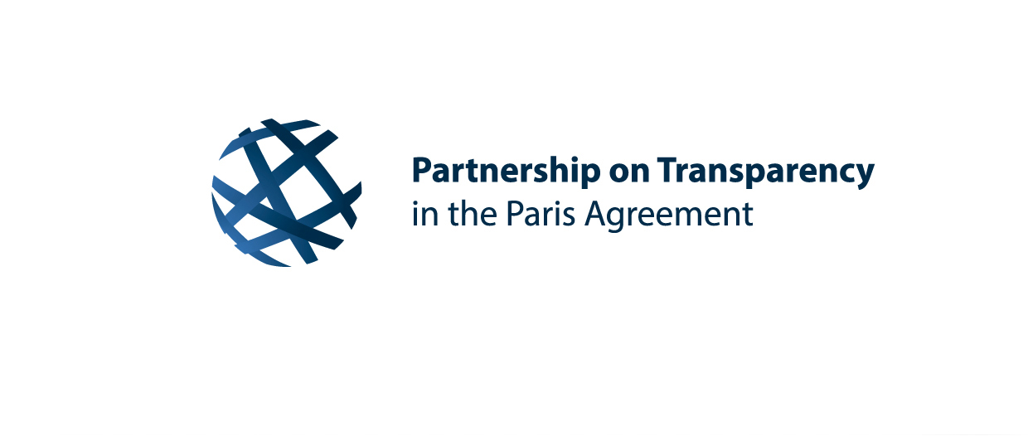


This journal belongs to:

_________________________________

24 – 26 September 2024 | Seoul, Republic of Korea
PATPA Asia Regional Workshop

You can find all the presentations, exercises and materials online: https://transparency-partnership.net/event/2024-asia-regional-workshop-finalisation-countrys-first-biennial-transparency-report-btr

Morning Reflection Day 1: Tuesday, 24 September 2024

Some initial questions…

Where does my country stand in the preparation of the first BTR?

What am I bringing to the workshop?

What am I hoping to take away from this event?

End of the Day Reflections from Day 1

What did I learn today?

What can I take home with me?

Where should I focus my energy on Day 2?

Who would I like to have conversations with during the next days?

Morning Reflection Day 2: Wednesday, 25 September 2024

What do I hope to take away from today’s session?

Which challenges or open questions would I like to address?

Halftime…

What did I learn today?

What can I take home with me?

Where should I focus my energy on Day 3?

Who would I like to have conversations with on the final day?

Morning Reflection Day 3: Thursday, 26 September 2024

Which topics would I like to discuss further?

General Reflections from Day 3

During the workshop, I had talks with….

I think that youth could be more incorporated in these processes…

These are the ideas I am taking with me…

My next steps are…

I want to address these open questions in the workshop follow-up
“Ask the experts” session:

